**Web Application Development**

**Assignment 2**

**Student Name: Lea Hung**

**Student ID: 2222026**

IDE:

An integrated development environment (IDE) is a software tool that improves programmer productivity by combining code editing, construction, testing, and packaging in a user-friendly interface (What Is an IDE? IDE Explained - AWS, 2024).

The IDE provides code editing automation, smart code completion, syntax highlighting, code reconstruction, automatic execution of compilation, testing and debugging, etc., thereby promoting team collaboration and enabling developers to compile code and execute native unit tests and debugging lines of code to increase productivity and reduce errors along the production line (What Is an IDE? IDE Explained - AWS, 2024).

Visual Studio is one of the integrated development environment developed by Microsoft which is adapted for this project. It is used to develop computer programs, including websites, web applications, web services, and mobile applications. Visual Studio has Windows API, Windows Forms, MVC framework in its software development platform which helped produced the project.

Its integration allows all code editing, debugging, testing and deployment tools to operate on the same system, and its rich ecosystem allows developers to work on projects and projects across multiple platforms, also tailor it to their needs.

Design Pattern:

The ASP.NET framework provides an integrated scaffolding system that can be extended through NuGet, project templates that support HTML5, presentation views with the Razor view engine, powerful hooks through dependency injection and global operation filters, and rich JavaScript support (including unobtrusive JavaScript, jQuery validation, and JSON) bindings, ASP.NET Web API, updated and modernized defaults and new mobile project templates, support for many features in mobile apps, and enhancements to asynchronous methods support (Rick-Anderson, 2023).

In this project, the MVC framework helps improve project scalability, and Razor views include forms that make the site interactive. Dependency injection improves the maintainability of the website and the dependencies between components, which makes it is easier to make modification. Scaffolding is a powerful tool that automates identity creation and CRUD operations. APIs help build HTTP services, and security features help build secure web applications. Implementation of the Repository classes facilitated in separating data access logic.

Database management system:

ASP.NET Core provides powerful performance when paired with SQL Server, which enables fast query execution and data retrieval due to SQL Server's powerful storage engine and indexing system. SQL Server's powerful security features, including encryption, authentication, and authorization, ensure a secure platform for sensitive data (The Advantages of Using ASP.NET Core with SQL Server, 2023). Both technologies offer exceptional scalability to handle large volumes of data and traffic, and since they are both Microsoft products, interoperability is seamless (The Advantages of Using ASP.NET Core with SQL Server, 2023).

When creating this project, if there is need to modify the data or check whether the data has been stored in the file, it allows direct access, write and modification in SSMS. With SSMS as the backend database management system for storing application data, this will effectively facilitates in understanding whether the code is working correctly, and deploying the project to the Microsoft Azure cloud can achieve scalability and disaster recovery purposes.

Connection to database:

ASP.NET provides two main methods of connecting to a database: data source control or custom ADO.NET/LINQ code (Archiveddocs, 2014).

Data source controls (such as LinqDataSource or SqlDataSource) provide easy data retrieval and modification for other controls, simplify setup and configuration, and allow reuse of connection details stored centrally in the Web.config file (Archiveddocs, 2014).

The connection string stores the necessary database connection information and can be managed centrally in the Web.config file and ADO.NET providers, such as System.Data.SqlClient and System.Data.OleDb, communicate with specific types of auxiliary databases (Archiveddocs, 2014).

Using ADO.NET for customized data access is suitable for complex scenarios or situations that require separation of concerns.

For this project, connect to a SQL Server database using Entity Framework allow easy interaction with data through object-oriented programming.

Software architecture:

ASP.NET includes multiple components, including programming languages ​​such as C#, VB.NET, and J#, each with its own compiler (What Is ASP.NET? Definition, Components and Benefits | Indeed.com, n.d.). The base library provides standard functionality for data processing, while the editors and tools ensure compatibility across different operating system environments. All ASP.NET programs execute on the common language runtime (CLR), which manages basic tasks such as exception handling and garbage collection (What Is ASP.NET? Definition, Components and Benefits | Indeed.com, n.d.).

In addition, ASP.NET introduces web development features such as an authentication system, client-side scripting using JavaScript, and editor extensions such as syntax highlighting (What Is ASP.NET? Definition, Components and Benefits | Indeed.com, n.d.). It supports model view controllers and Razor templates using C# dynamic web pages, state management and caching mechanisms to ensure efficient application performance and response times.

Components:

In this project, the model, view, and controller components create the organization for the project and the repository handles database interaction and data access logic, the view model transfers data between the view and controller, ensuring separation, and finally, there is the scaffolding identity for managing user authentication and authorization.

Interaction:

In this project, the controller interacts with the repository to get or modify data, the view renders the data received from the controller and passes user actions back to the controller, while the dependency injection container injects dependencies into the controller and finally the repository layer Interact with Entity Framework for SSMS database operations.

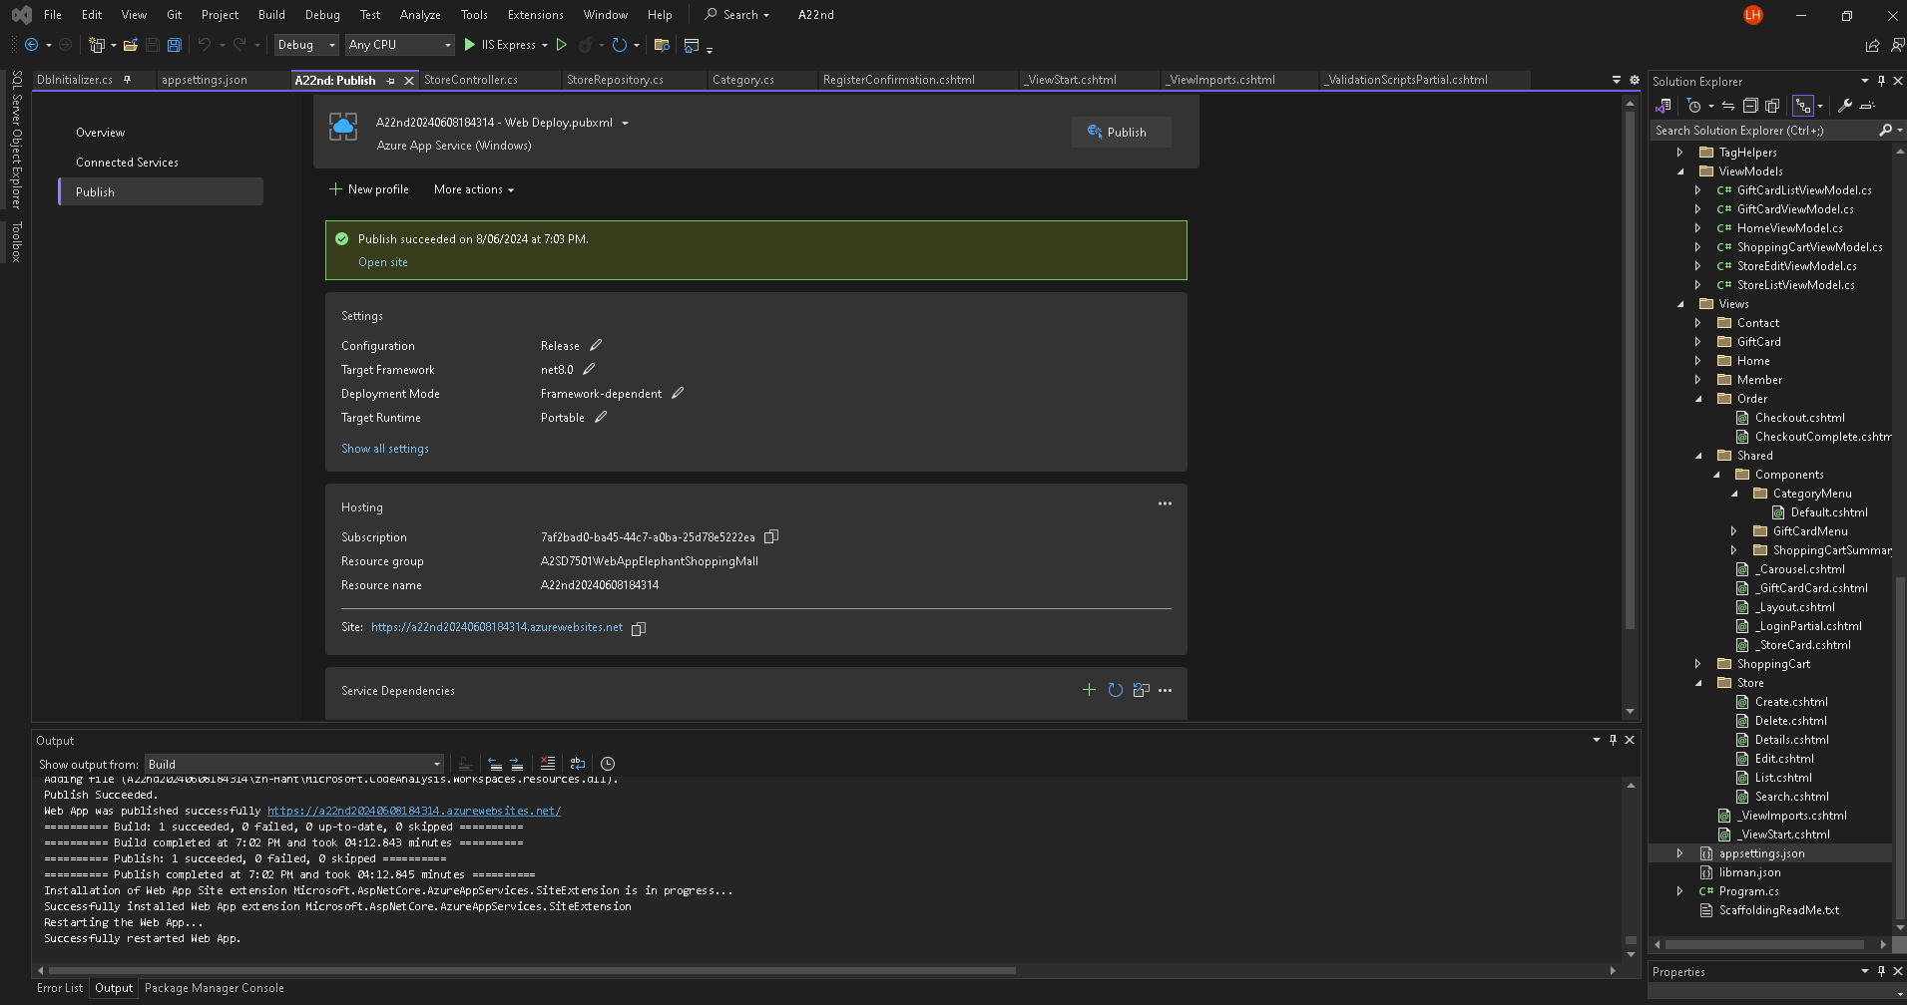

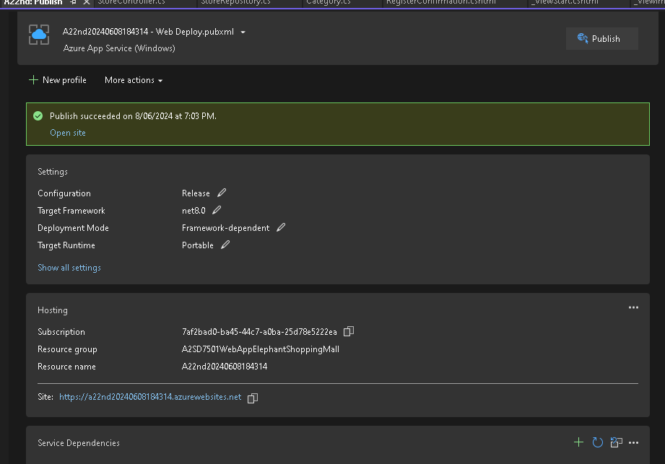

References:

*What is an IDE? IDE Explained - AWS*. (2024). Amazon Web Services, Inc. https://aws.amazon.com/what-is/ide/#:~:text=An%20integrated%20development%20environment%20(IDE

Rick-Anderson. (2023, June 24). *ASP.NET MVC 4 Overview*. Learn.microsoft.com. https://learn.microsoft.com/en-us/aspnet/mvc/mvc4

*The Advantages of using ASP.NET Core with SQL Server*. (2023, February 27). Intertoons Internet Services Pvt.Ltd. https://intertoons.com/the-advantages-of-using-asp-net-core-with-sql-server-2.html

Archiveddocs. (2014, October 22). *Connecting to Databases in ASP.NET*. Learn.microsoft.com. https://learn.microsoft.com/en-us/previous-versions/aspnet/ms178371(v=vs.100)

*What Is ASP.NET? Definition, Components and Benefits | Indeed.com*. (n.d.). Indeed Career Guide. https://www.indeed.com/career-advice/career-development/what-is-aspnet

‌